HEART RATE SENSOR USING RASPBERRY PI WITH SMS ALERT

AHMAD SOLEHIN BIN SHARUDDIN

A thesis submitted in fulfilment of the requirements

for the award of the degree of

Bachelor of Computer Science (Software Engineering)

Faculty of Computer System & Software Engineering

University Malaysia Pahang

JULY 2017

**UNIVERSITI MLAYSIA PAHANG**

**BORANG PENGESAHAN STATUS TESIS**

**JUDUL : HEART RATE SENSOR USING RASPBERRY PI WITH SMS ALERT**

**SESI PENGAJIAN : 2017/2018**

Saya **AHMAD SOLEHIN BIN SHARUDDIN**

**(HURUF BESAR)**

mengaku membenarkan tesis PSM ini disimpan di Perpustakaan Universiti Malaysia Pahang dengan syarat-syarat kegunaan seperti berikut :

1. Tesis adalah hakmilik Universiti Malaysia Pahang

2. Perpustakaan Universiti Malaysia Pahang dibenarkan membuat salinan untuk tujuan pengajian sahaja.

3. Perpustakaan dibenarkan membuat salinan tesis ini sebagai bahan pertukaran antara institusi pengajian tinggi.

4. **Sila tandakan ( √ )

SULIT (Mengandungi maklumat yang berdarjah keselamatan atau

kepentingan Malaysia seperti yang termaktub di dalam

AKTA RAHSIA RASMI 1972)

TERHAD (Mengandungi maklumat TERHAD yang telah ditentukan

oleh organisasi/badan di mana penyelidikan dijalankan)

√ TIDAK TERHAD

Disahkan oleh

(TANDATANGAN PENULIS) (TANDATANGAN PENYELIA)

Alamat Tetap: No 9 Lorong Kubang Buaya 82, **DR. ROHANI BINTI ABU BAKAR**

25250 Kuantan , Pahang  Nama Penyelia

Tarikh : 29 DISEMBER 2018 Tarikh: 29 Disember 2018

# STUDENT DECLARATION

# I hereby declare that the work in this thesis is my own except for quotations and summaries which have been duly acknowledged.

|  |  |  |
| --- | --- | --- |
| Student | : | ...................................................................... |
|  |  | AHMAD SOLEHIN BIN SHARUDDIN  CB15003 |
| Date | : | ...................................................................... |

# SUPERVISOR DECLARATION

# I hereby declare that I have read this thesis and in my opinion this thesis is sufficient in terms of scope and quality for the award of the degree of Bachelor Of Computer Science Software Engineering.

|  |  |  |
| --- | --- | --- |
| Supervisor | : | ...................................................................... |
|  |  | DR.ROHANI BINTI ABU BAKAR |
| Date | : | ...................................................................... |

# ABSTRACT

# Malaysia is well known for its unique food that attracts the attention of travelers, multinationals such as Malay, Chinese and Indians who are sure to have their own tradition of food inherited from the earliest days. The variety of delicious foods that can contribute to the increase in calories and chronic illnesses such as heart attacks. In addition, the number of smokers in Malaysia is increasingly contagious among the masses as well as the factors for heart attack.

# Based on the research conducted by the experts, the Malaysian people have a lazy personality in order to adopt a healthy and balanced diet. If observed, Malaysia have big population overweight no matter the man or woman. Additionally, they provide work as a barrier to practicing balanced diet and light exercise. Additionally, with the busy work of making yourself to seek advice and examination from a doctor. Some people are afraid to make health treatments and think they are always healthy. Therefore, Heart rate sensor using raspberry PI with SMS alert intends to detect heart rate every minute and display them without going to the hospital to check using a raspberry pi device by alerting the SMS notification.

Therefore, the project aims to detect heart rate every minute and to show them without going to the hospital to check using a raspberry pi device by alerting the SMS notification. This app may use all generation to detect heart rate and may be affordable .

**TABLE OF CONTENTS**

|  |  |  |
| --- | --- | --- |
|  | **TITLE**  **THESIS STATUS DECLARATION** | i  ii |
|  | **STUDENT DECLARATION**  **SUPERVISOR DECLARATION** | iii  iv |
|  | **ABSTRACT** | v |
|  | **TABLE OF CONTENTS** | vii |
|  | **LIST OF FIGURES** | ix |
|  | **LIST OF TABLES** | x |
|  |  |  |
| **1** | **INTRODUCTION** | 1 |
|  | 1.1 Project Background | 1 |
|  | 1.2 Problem Statements | 2 |
|  | 1.3 Objective | 3 |
|  | 1.4 Scope | 3 |
|  | 1.5 Project Significant | 3 |
|  | 1.6 Report Organizations | 4 |
| **2** | **LITERATURE REVIEW** | 5 |
|  | 2.1 Introduction | 5 |
|  | 2.2 Detect and Effect or Heart Attack | 6 |
|  | 2.3 Review Of Existing System | 7 |
|  | 2.3.1 Instant Heart Rate Apps | 7 |
|  | 2.3.2 Cardiograph | 8 |
|  | 2.3.3 Runtastics Heart Rate Apps | 8 |
|  | 2.4 Comparison Feature Existing System | 10 |
|  | 2.6 Conclusion | 10 |
| **3** | **METHODOLOGY** | 11 |
|  | 3.1 Evolutionary Prototyping Model | 11 |
|  | 3.1.1 Planing Phase | 12 |
|  | 3.1.2 Analysis Phase | 13 |
|  | 3.1.3 System Design Phase | 13 |
|  | 3.1.4 Implementation Phase | 15 |
|  | 3.1.5 Prototype Phase | 15 |
|  | 3.1.6 Testing Phase | 16 |
|  | 3.2 Milestone | 16 |
|  | 3.3 Hardware Requirements | 17 |
|  | 3.3.1 Software Requirements | 17 |
| **4**  **5** | 3.4 Conclusion  **IMPLEMENTATION**  4.1 Introduction  4.2 Implementation Requirement  4.2.1 Hardware Implementation  4.2.2 Finger Clip Detection Implementation  4.2.3 Software Implementation  4.3 Testing Phase    **CONCLUSION**  5.1 Introduction  5.2 Research Constraint  5.3 Future Works  5.4 Conclusion | 18  19  19  19  20  20  22  24  26  26  26  26  27 |
|  | **REFERENCES** | **28** |
|  |  |  |

**LIST OF FIGURES**

1.1 Problem Heart Diseases 5

2.1 Interface Instant Heart Rate Apps 11

2.2 Interface Of Cardiograph Apps 12

2.3 Interface Runtastic Heart Rate Monitor 13

3.1 Evolutionary Prototyping Model 16

3.2 Context Diagram 18

3.3 Use Case Diagram 18

3.4 General Architecture 19

4.1 Testing Prototype 21

4.2 Code for heart rate sensor 22

4.3 Home Page 22

4.4 Coding generate chart 23

4.5 Line graph chart 25

4.6 Testing Phase 25

**LIST OF TABLES**

2.1 Comparison with Existing System 14

3.1 Achievement Phase 20

3.2 Hardware Requirements 21

2.2 Software Requirements 21

3.1 Achievement Phase 22

3.2 Hardware Requirement 23

3.3 Software Requirement 24

# CHAPTER 1

**INTRODUCTION**

# Project Background

Healthy is an important aspect of our lives. It has a direct influence on how we live our daily lives. To ensure that we are always on the go without any illness, the Department of Health Malaysia has always requested and warned us to make an inspection to ensure that we do not have chronic diseases such as heart attack and kidney disease. Citizen give a reason to work more importantly than their health and do not have time to medical checkup.

So, this project aim to develop an apps that can monitor pulse of heart rate using rapsberry pi and send a warning alert notification if data is more than 90 bpm. This application can help people to make early checkup or monitor only to get treatment and advice. But, still need to go hospital to get advice from the doctor even though busy.

.

# Problem Statement

Figure 1.1 : Problem Heart Disease

WHO recorded data published in 2017 Coronary Heart Disease Deaths in Malaysia reached 30,598 or 22.13% of total deaths. Population ranks Malaysia age 63 Death Rate is 137.02 per 100,000. Well known as the food heaven, it is surely hard for Malaysians to part from their favourite local delicacies like nasi lemak, roti canai, mee goreng, and all those mouthwatering desserts that we love but are deadly dangerous to us after all.

Besides that, all the delicious food will produced calories and fat. Heart disease strikes everyone regardless of gender, age or weight. Citizen lack of awareness to prevent their life from get this problem heart disease

# Objective

The project purpose to develop the heart rate sensor using raspberry PI with SMS alert and in order to achieve this aim, we divide into following objectives.

1. To develop a system which combine software and hardware using IOT and Mobile APPS.
2. As a first step in preventing hear atteck
3. To monitor and reduce the rate of heart disease death rates.

# Scope

In order to achieve the project objectives, there are few parts of the scope in this project..

1. To detect heart rate only
2. To notify registered user with sms alert
3. Notify the user about registered user heart rate bpm through Twilio Api.

# Project Significant

In this present scenario, it is not possible for a doctor to observe a patient’s heart rate per minute all the time. This project to make useful for everyone in this society. Again a doctor far away from the patient need to know heart rate for initial treatment . An embedded system which can measure the heart rate and store the data for the doctor to know the condition of the patient can help for this purpose The device will allow one to measure their mean arterial pressure (MAP) in about one minute and the accurate will be displayed on the mobile apps and via text messaging.

# Report Organization

There are five total chapter in this thesis:

**Chapter 1** is an introduction to the project. This chapter also explain about backgrounds, problem-solving projects, objective projects, and scope projects that can be archive in this chapter.

**Chapter 2** is a Literature Review. In this chapter the subject to be discussed is the analysis of the existing system and the problems faced by the system. This chapter also reviews the existing system by looking at factors such as functions, technologies and weaknesses of the system. Discussions and similarities between the systems that have been studied are discussed at the end of this chapter.

**Chapter 3 (Methodology)** describes the general structure and operations of the system, including all assumptions and considerations for the system‘s operation.

**Chapter 4** describes the implementation and testing of the system. Quality testing discusses the usability, efficiency, security, needs, and reliability of a system in order to achieve a requirements.

**Chapter 5** is a conclusion that discusses the advantages, disadvantages and conclusions of the overall development project of the system together with the proposed improvements.

# CHAPTER 2

**LITERATURE REVIEW**

## Introduction

The heart is the organ that mindful for pumping blood all through the body. It is found in the center of the thorax, somewhat balanced to the cleared out and encompassed by the lungs fundamentally; the human heart is composed of four chambers which are two atriums and two ventricles. The right chamber gets blood returning to the heart from the entirety body. That blood passes through the right ventricle and is pumped to the lungs where it is oxygenated and goes back to the heart through the cleared out chamber, and at that point the blood passes through the cleared out ventricle and is pumped once more to be dispersed to the whole body through the supply routes.

A heart assault happens when there is a sudden total blockage of an supply route that supplies blood to an zone of your heart. A heart is a muscle, and it needs a great blood supply to keep it solid. As we get more seasoned, the smooth inward dividers of the supply routes that supply the blood to the heart can ended up harmed and contract due to the construct up of greasy materials, called plaque. When an region of plaque breaks, blood cells and other parts of the blood adhere to the harmed range and shape blood clots.

A heart assault happens when a blood clot totally pieces the stream of blood and genuinely diminishes blood stream to the heart muscle. This moreover comes about in patients encountering chest Stick. As a result, a few of the heart muscle begins to kick the bucket. The longer the blockage is cleared out untreated, the more the heart muscle is harmed. In the event that the blood stream is not reestablished rapidly, the harm to the heart muscle is lasting. A heart assault is some of the time called a myocardial dead tissue (MI), intense myocardial dead tissue, coronary impediment or coronary thrombosis.

## Detect and effect or heart attack

Few heart assaults are sudden and strongly. But most begin gradually, with gentle Stick or distress. Here are a few of the signs that can cruel a heart assault is happening:

 • Chest inconvenience.

Most heart assaults include distress in the center of the chest that lasts more than a few minutes, or that goes absent and comes back. It can feel like awkward weight, crushing, totality or Stick.

Inconvenience in other regions of the upper body. Symptoms can incorporate Stick or distress in one or both arms, the back, neck, jaw or stomach.

 • Shortness of breath.

 May happen with or without chest inconvenience.

 • Other signs:

 These may incorporate breaking out in a cold sweat, queasiness or wooziness.

 As with men, women’s most common heart assault indication is chest Stick or inconvenience. But ladies are more likely than men to have a few of the other common indications, especially shortness of breath, nausea/vomiting, and back or jaw Stick.

## Review of Existing System

### Instant Heart Rate Apps

Moment Heart Rate moreover measures your heart rate by dissecting your tip of the Record finger utilizing the phone’s camera. To screen your heart rate you have to put your finger tip in the camera focal point. This app will dissect and track your heart rate. The Heart rate will show up in the screen after a few time.

A real-time chart will appear each heartbeat. It employments your phones built-in camera to track color changes on the fingertip that are specifically connected to your beat. This is the same strategy that restorative beat oximeters utilize. For the most excellent result utilize this great lighting condition, in the event that your phone doesn’t have a streak light.

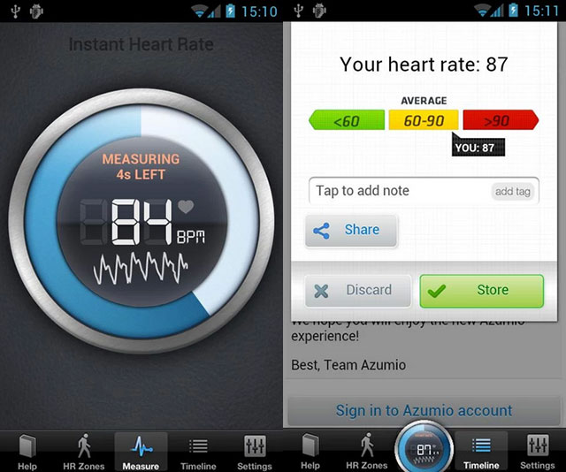

**Figure 2.1 Interface Instant heart rate apps**

### Cardiograph

Cardiograph employments your device's camera to degree your heart rate. The plan is straightforward and clean, making it exceptionally simple to utilize. You can log information for numerous individuals with person profiles all in one account. Track your heart rate over time to see how your wellness changes. Send out your information to share with your wellbeing proficient or keep for your possess records. The Android app is outlined to work with Android Wear shrewd observe beat locators as well.

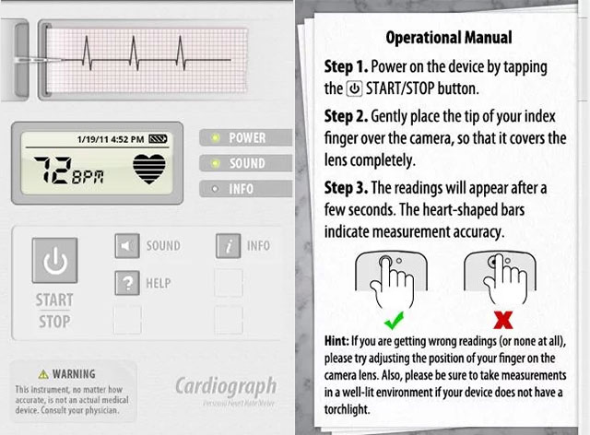

**Figure 2.2 Interface of cardiograph apps**

### Runtastics Heart Rate Apps

Runtastic Heart Rate app moreover employments the same innovation like the past apps. It employments the Camera sensor to degree your Beat Rate. This free app will degree your pulse with incredible precision. see HRM comes about in a chart. One of the most excellent highlight of this app is Staggering Interface that looks extraordinary on phone. It offers assortment of diverse, moment estimation sorts: resting HR, most extreme HR, and HR before/after cardio .

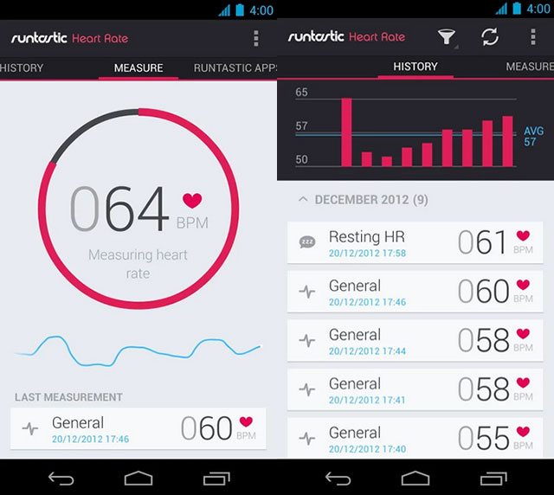

**Figure 2.3 Interface Runtastic Heart Rate Monitor**

## Comparison Feature Existing System

|  |  |  |  |
| --- | --- | --- | --- |
| **Features** | **Instant Heart Rate** | **CardioGraph** | **Runtastic** |
| Developer | azumio | MacroPinch Ltd. | Runtastic Team |
| Platform | Android  Ios | Ios | Android  ios |
| Advantage | * Available for iphone and android * Fast to use * Storage and sharing options | * Easy to use, everything on one screen * Emailing and printing options * One can use either camera | * Works through Bluetooth, starts when you start the Runtastic apps |
| Disadvantage | * Hard to use without a flash * Smudges the camera lens | * Difficult to get an accurate measurement right off the bat. | * Our smartphones did not always pick it up automatically |

Table 2.1 : Comparison with existing system

## Conclusion

In this chapter, we already discuss about three existing system that similar with evaluation system. Then, we discuss the details of three existing system and their features to making a comparison. Based on the advantage and disadvantage from three existing systems, there are some features that we can use to develop this system.

# CHAPTER 3

**METHDOLOGY**

This chapter discusses the software development methodology used to develop the Heart Rate Sensor Using Raspberry PI with SMS Alert. The methodology used is the Evolutionary Prototyping Model. The chapter will discuss the main phases in the methodology as well as activities for each phase.

## Evolutionary prototyping model

The main phases in the selected prototyping model are Planning, Analysis, Design, Implementation, Prototype and Testing as shown in Figure 3.1 whereby the Prototype and Testing phases are depicted together as System Prototype. The researcher conducts initial planning and analysis followed by three iterations of the phases: analysis, design and implementation whereby each iteration will produce a prototype which will be tested to further enhance the researcher’s understanding of the system’s requirements. The third and final iteration will be implemented as the finalized system. The developer ascertained that it is the most suitable methodology for the system to be developed in after considering constraints such as project duration and the researcher’s expertise in the domain. The following section will explain the activities carried out in each phase.

Figure 3.1 depicts the main phases in the selected model

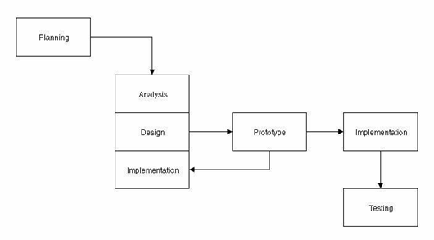

Figure 3.1: Evolutionary Prototyping Model (Dennis, Wixom & Tegarden, 2010)

### Planning phase

In this early phase, the researcher identifies the problem statement and objectives of the system as well as determines the scope of the system. This is followed by selection of a suitable title for the project and formation of a business case in the form of a project proposal. Based on the proposal, a Gantt chart (refer Appendix D) is prepared to list down the activities to be conducted for the completion of the project in a timely and systematic manner.

### Analysis phase

In the analysis phase, the requirements for the system were determined via various means. Firstly, the researcher conducted informal interview sessions with the staff in Pusat Kesihatan University UMP (refer Appendix E). The expert knowledge obtained is then combined with background information from theses and reference materials both from the internet and the library to determine the functionality that the system must provide. This collective information is then used to make comparisons with similar systems to identify the typical functionality that heart rate monitor and decision support systems provide. The comparisons will be used as references for the system to be developed as a product of the analysis. All elicited requirements are then documented in the form of a Use Case Diagram and Use Case Specification, Sequence Diagram and Activity Diagram for each use case as well as a Requirement Traceability Matrix. Other than that, the researcher also identified all the software and hardware requirements to develop the system. The following sections will explain the hardware and software requirements for the system

### System Design Phase

In the design phase, the researcher designed the interfaces for the mobile application, the schematic for the Raspberry Pi prototype as well as the architecture for the integration between the Raspberry Pi prototype and the mobile application. Among the interfaces designed for the mobile application are the User detail activity and heart rate activity. Furthermore, the structure of the system is designed with detail in the form of a Context Diagram, Use Case Diagram and general architecture and package Module .While all details about design will discuss in Software Design Document(SDD).

#### **Context Diagram**

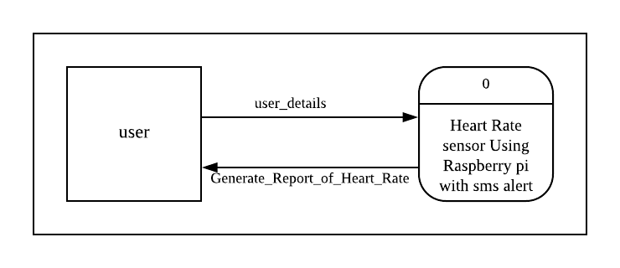

Figure 3.2: Context Diagram

#### **Use Case Diagram**

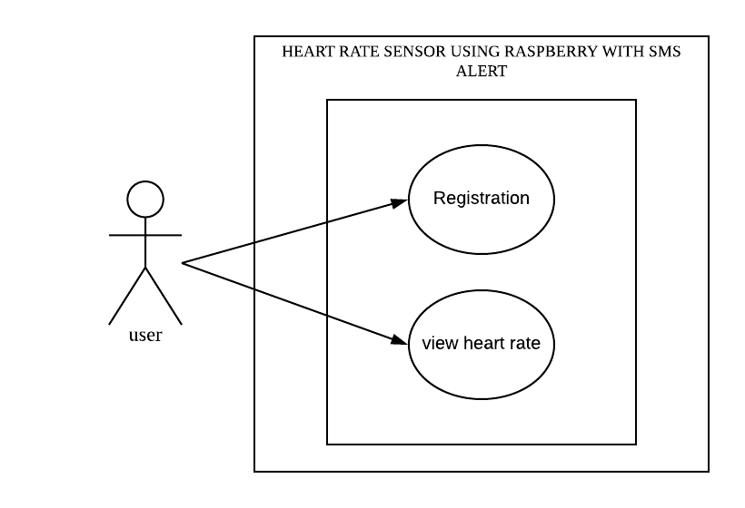

Figure 3.3: Use Case Diagram

### Implementation phase

In the implementation phase, the system design will be translated to running code in python with the aid Phone gap Cordova. The compiled application will then be executed in the Phone gap Cordova.

### Prototype

### In this phase, the researcher will develop three iterations of prototype systems based on stakeholders’ specifications. Each prototype will be presented to the stakeholders and tested to ensure that it meets the objectives, is within the defined scope and fulfills all requirements without exceptions. All flaws identified during the testing will be documented and fixed in the following iteration. The first prototype will involve the development of interfaces for all modules in the mobile application. In the second iteration, the interfaces for the mobile application will be revamped and the raspberry PI will be interfaced with the heart rate module to transmit sensor data to raspberry platform. Next, in the third and final iteration, the mobile application will be enhanced with decision support logic to provide meaningful notification (sms) based on the data obtained from the raspberry PI.

### Testing Phase

In this phase, the prototype is tested by the stakeholders to ensure that all system requirements are enough. This phase is to ensure that the developed system reaches the objective user. If there is a change in the need or improvement system, the iteration formatting process, the initial design and implementation and the new prototype model are developed to achieve the desired needs of the stakeholders.

## Milestone

There are six main phases in the prototyping model used namely the Planning phase,

the Analysis phase, the Design phase, the Implementation phase, the Prototype phase

and the Testing phase. The specification of activities carried out for each phase is

depicted in Table 3.1.

Table 3.1: Achievement Phase

|  |  |  |
| --- | --- | --- |
| **Phase** | **Tasks** | **Milestones** |
| **Planning** | - Select title  - Perform background study  - Identify the problems  - Determine the objectives and scope  - Perform literature review on existing  Systems  - Schedule the tasks | - Proposal  - Gantt Chart |
| **Analysis** | - Make a list of stakeholders and field experts  - Interview field expert in raspberry PI and  - Elicit requirements from target users  - Compile the requirements  - Prioritise the requirements  - Analyse feasibility of the requirements | - Use Case Diagram  - Use Case Specification  - Activity Diagram  - Sequence Diagram  - Requirement Traceability  Matrix |
| **Design** | - Design the raspberry prototype  - Simulate the raspberry prototype  - Design the database as per requirement  - Design the user interface as per requirement | - Class Diagram  - Schema table  - Interfaces |
| **Implementation** | - Translate design to running code | - Executable system |
| **Prototype** | - Present prototype to stakeholders | Prototype 1 : Complete  interface with working sensor  output from raspberry  Prototype 2 : Interface the  mobile application and the  raspberry prototype  Prototype 3 : Add notification (sms) |
| **Testing** | - Alpha testing  - Beta testing | Alpha testing  Beta testing |

## Hardware Requirement

The hardware to be used in the development of the Heart Rate Sensor using Raspberry PI with SMS Alert is depicted in Table 3.1.

Table 3.2: Hardware requirements

|  |  |  |  |
| --- | --- | --- | --- |
|  | **Hardware** | **Quantity** | **Usage** |
| 1 | Laptop | 1 | Writing documentation and write code |
| 3 | Printer HP | 1 | Print documentation |
| 4 | Raspberry PI | 1 | Determine the heart rate and send notification (SMS). |
| 5 | Finger Clip Sensor | 1 | Capture pulse data of heart disease |

### Software Requirement

The software to be used in the development of the Real-time D-MON system is

depicted in Table 3.3.

Table 3.3: Software requirement

|  |  |  |  |
| --- | --- | --- | --- |
| **Bil** | **Software** | **Quantity** | **Usage** |
| 1 | Apache Phonegap Cordova | 1 | Construct the Mobile application |
| 2 | XAMPP PHPMYADMIN | 1 | Create database |
| 3 | Microsoft Office   * Microsoft Word 2013 * Microsoft Project 2013 * Microsoft Visio 2007 | 1 | Develop project schecule and gannt chart  Produce project document |
| 4 | Mac Os High Sierra | 1 | Operating system using |

## Conclusion

The prototyping methodology is used to ease the development process with respect to the time constraint. All activities carried out, tools used and technologies implemented for the development of the system have been discussed.

# CHAPTER 4

**IMPLEMENTATION & RESULT**

## Introduction

This chapter will discuss the implementation, testing and the result for this

project. The interface, code of the project and explanation for both hardware and

software will be provided for more clearly. Besides, the interaction between device

and mobile application is using Raspberry Pi as medium communication using

python code. The code allows to get data pulse of heart rate from glove sensor and

saved into the database.

On the other hand, the mobile application is developing to view the data

from database. The user details data will be passed within the mobile application,

however glove sensor is required to detect pulse of heart rate and send to Raspberry

Pi. Mobile application was implemented using HTML, Bootstrap 4 CSS, JavaScript,

Ajax and Canvas Js.

## Implementation Requirement

During implementation, installation of both hardware and software is an

important to make a list of equipment and software needed in the project. After study

carefully about the specification and type that suitable for project, the hardware and

software was chosen. All step of the installation was recorded for the references.

The device need to be set up such as glove sensor and Raspberry Pi. In order to

make glove sensor working properly, each pin must be correctly connected to

Raspberry Pi. Software must be installed before start implementation process. The

data will store in the real server, so that the data can be used in mobile application.

### Hardware Implementation

For this project, the raspberry Pi and glove sensor module will be used for

the hardware. Firstly, attached together the Raspberry Pi and glove sensor module by

using board. Make sure all each pin for the both component was correctly connected

to ensure the glove sensor module will be able to work properly and can use for this

project. Figure 4.1 shows the connection between each component. This system

using this prototype as testing by connecting between Raspberry Pi, board and glove

sensor module. Eight jumper must have connected properly in order glove sensor

module able to store data in database. Besides that, mobile application required

internet for the system able to work properly.

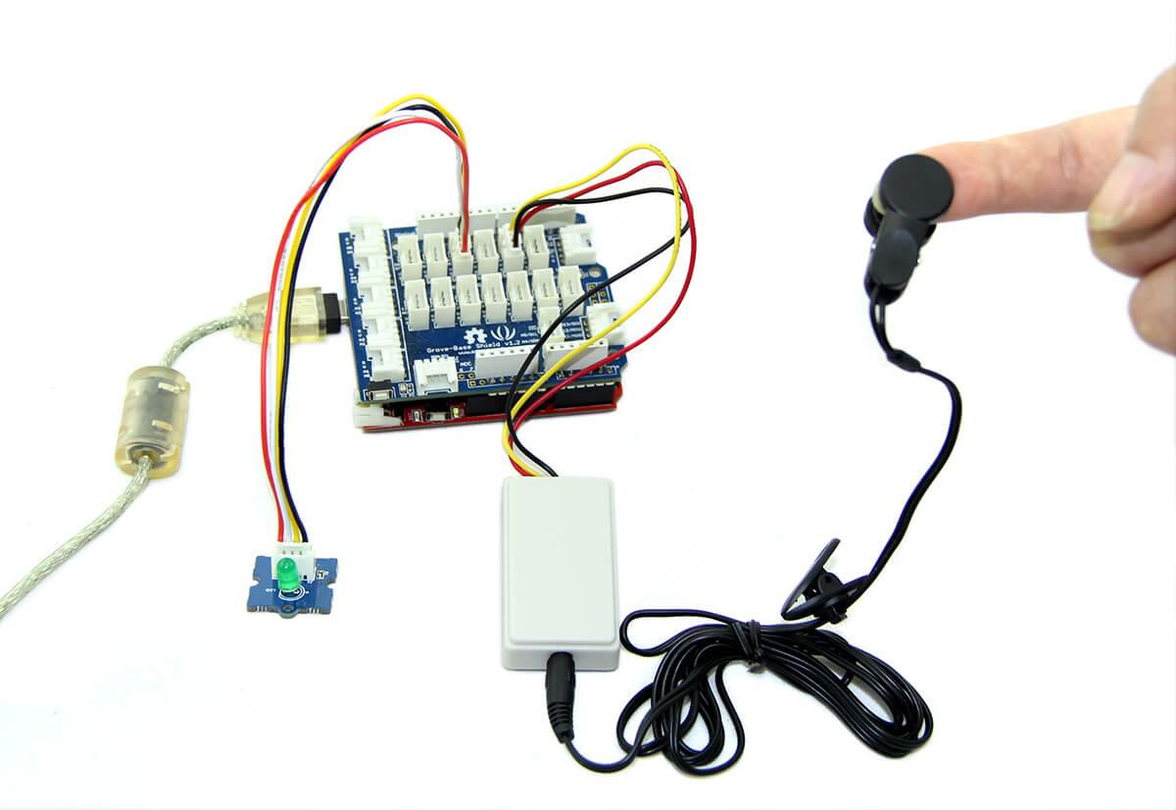

**Figure 4.1: Testing prototype**

### Finger Clip Detection Implementation

The objective of this project is to develop a system that detect a pulse of

heart rate using glove sensor module. After the sensor is able to capture the pulse of

heart rate, data will automatically recorded and send into database. Figure 4.3 shows

the python code for pulse of heart rate detection and database connection. Figure 4.4

show the record data that saved into the database from glove sensor module. By

having all these codes, this objective was achieved.

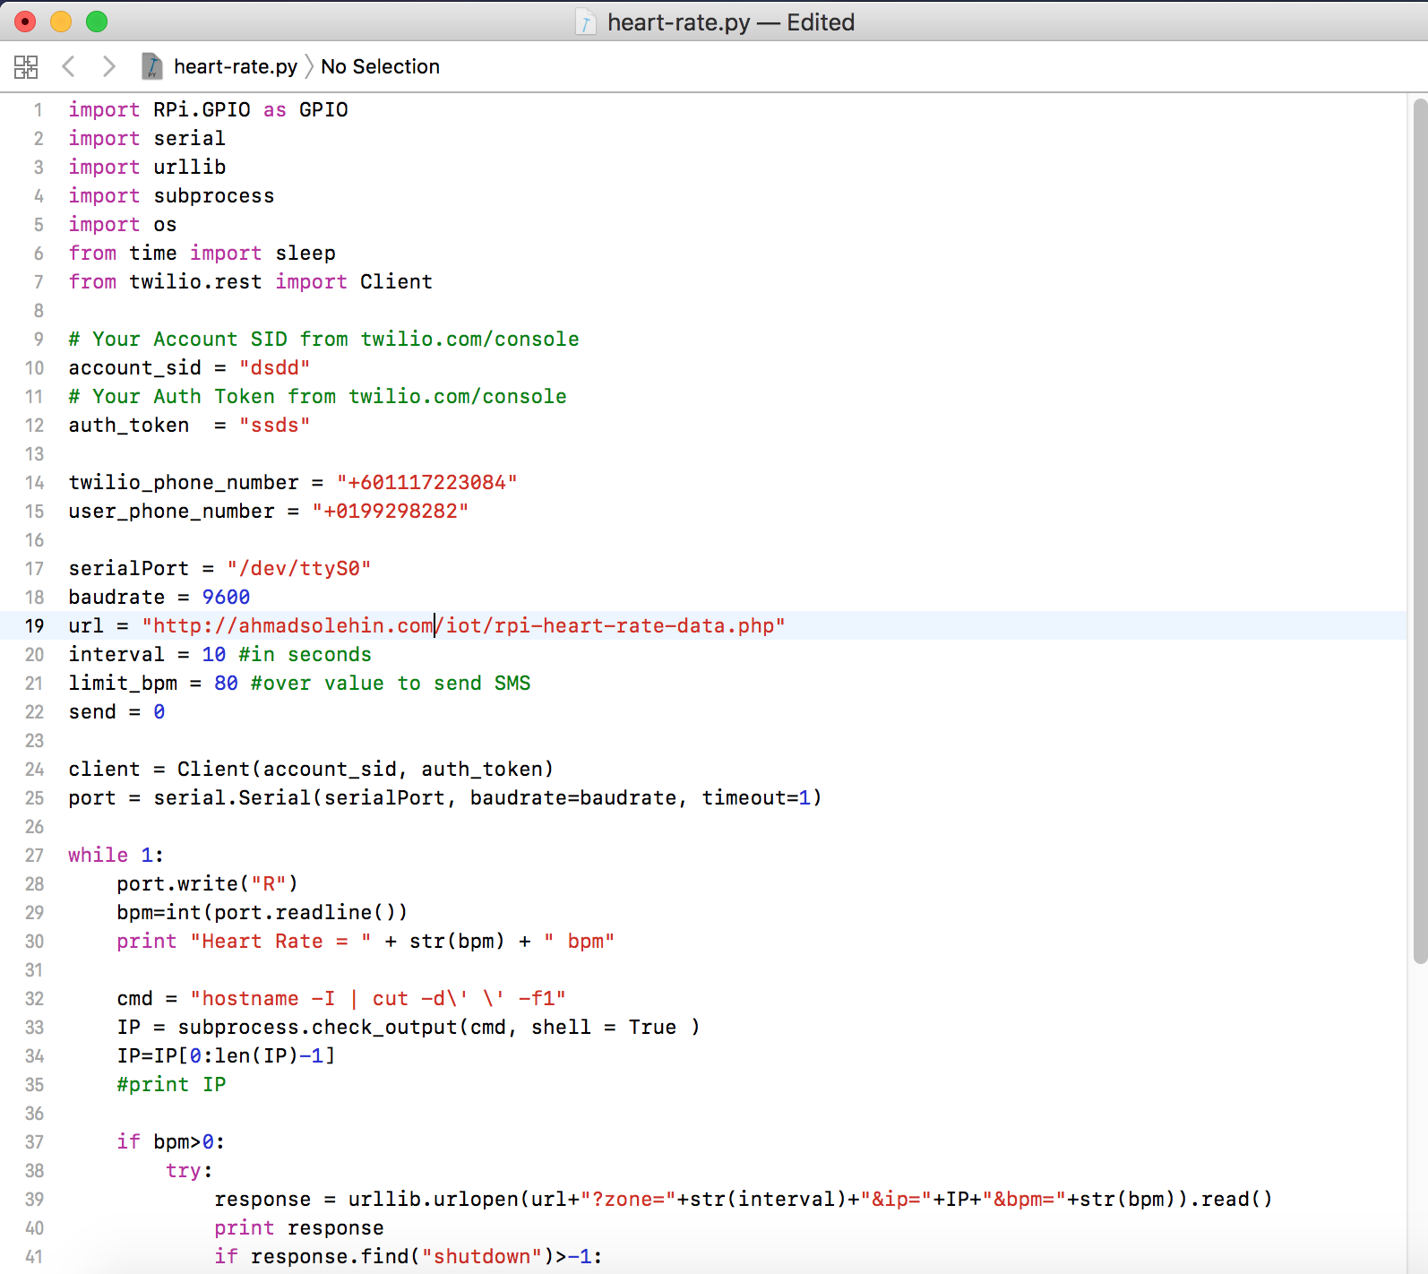

**REFERENCES**

[1] Dennis, A., Wixom, B. H., Tegarden, D. P., & Dennis, A. (2005). Systems analysis

and design with UML version 2.0: An object-oriented approach. Hoboken,

Figure 4.2: Code for heart rate sensor

This code is used to receive user details such as phone number, check the bpm heart rate and then send back the request to the mobile apps

### Software Implementation

### The next phases are software implementation of HRM mobile application is developed. User need to fill up the form to use the system. Data will be stored and retrieved based on the function used. Interface or front end of this application is using HTML, Bootstrap 4 Css Framework, Canvas Js, Ajax, and Jquery. For the server side or back end, Pure PHP is used. The ide used is Sublime 3. To generate a hybrid app from web based code, a software named Phone gap Cordova is being used to achieve this. Figure below are interface and code about the function related.

#### Index Page

This a index page of this application. It only has a one page and this is called SPA (Single Page Application). User need to fill up those form and then this chart will be generate automatically based on the pulse of heart rate. The data will be generating real time about 10 second (can set by a developer in python code). User also can see their heart rate bpm and raspberry pi ip address. The red button is used to refresh data while the blue button is to shut down the raspberry pi. Hence, this is the trickiest part, if the data of heart rate is more than 90, the function will have triggered to send message to phone number user via using twillio api.

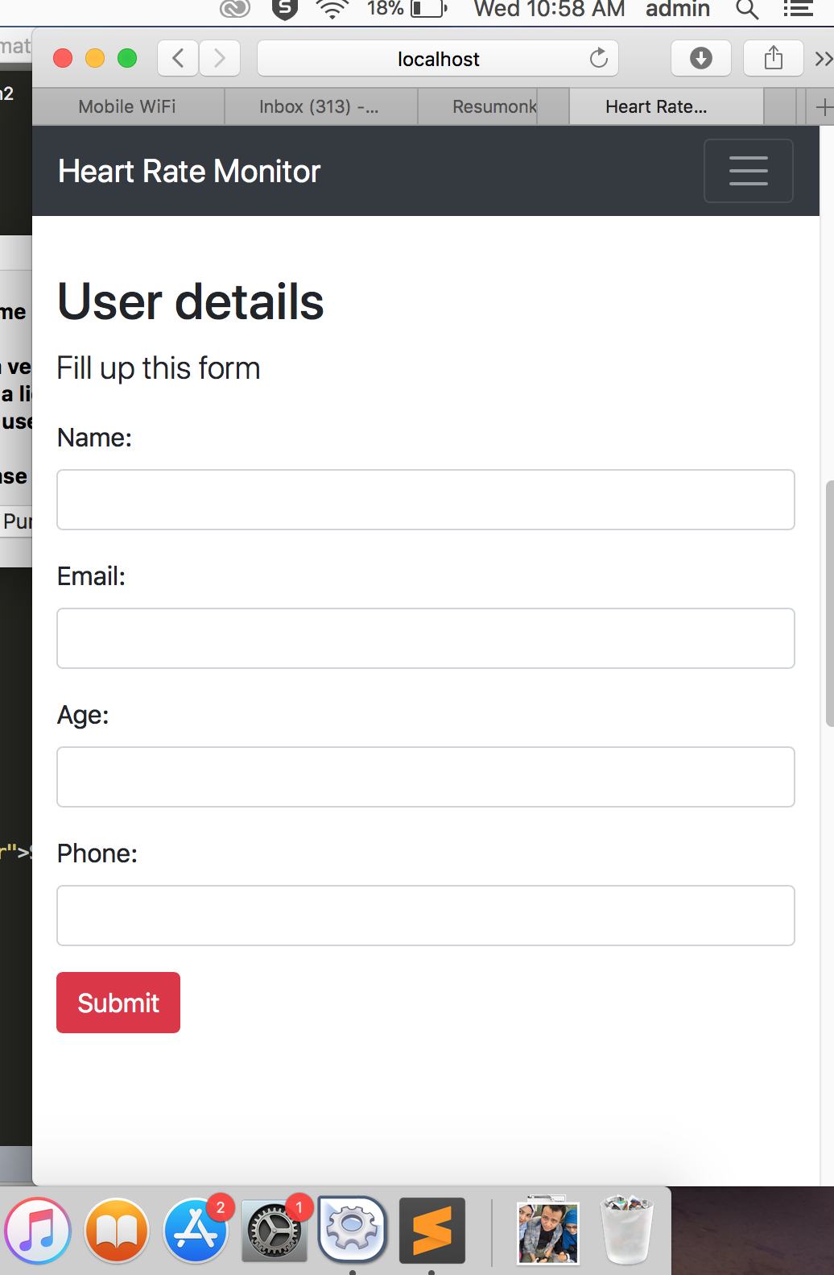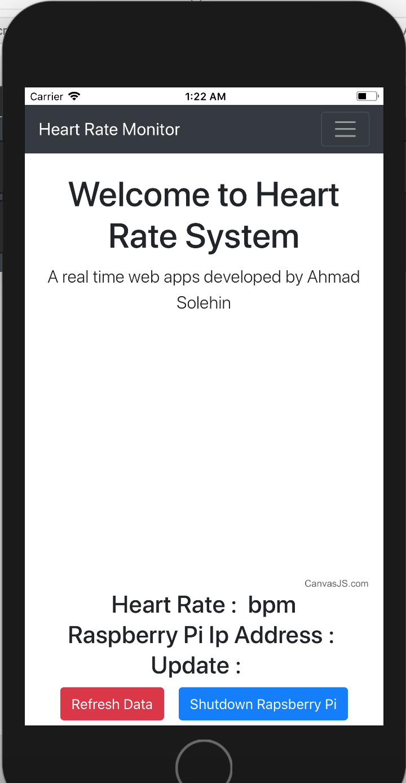

Figure 4.3 : Home page

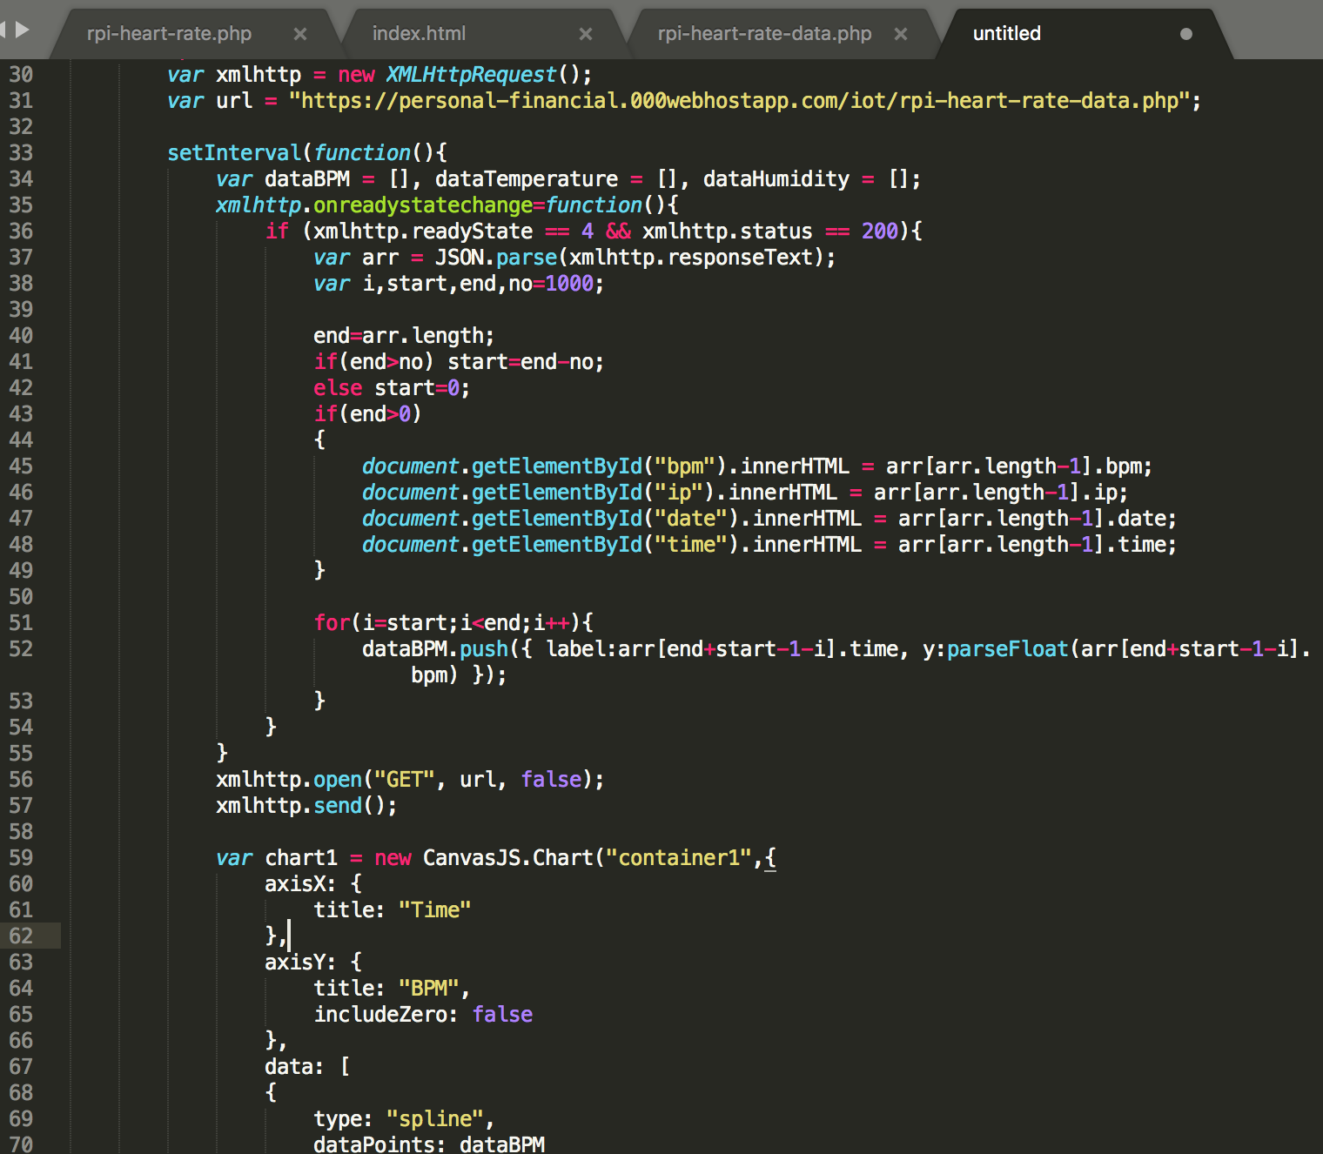

Figure 4.4 : Coding generate chart

code to generate chart from database using ajax xml.

#### Graph view page

This line chart is generate after user fill up the form. The data in this graph will

execute after the finger clip sensor get data and transfer to raspberry pi.

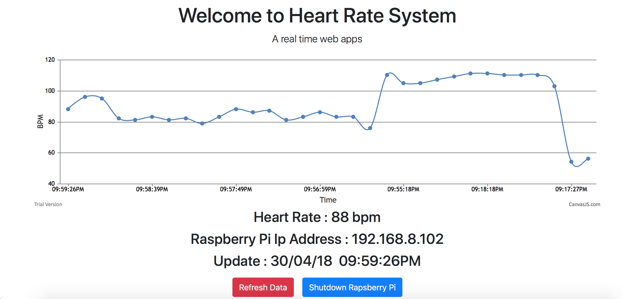

\

Figure 4.5 : Line chart graph

Api is created in real server ,taken using ajax xml to render the graph

### 4.3 Testing Phase

Last phases in this chapter is testing both application and device. Before deploy to client, it is important to test the system by checking system running without any error or debug as expected. There are two type testing that applying during the development processes which are white-box and black-box testing. Black-box is a method of testing which the testing is carried out by looking at the internal structure. White-box testing is carried out by examining the code and evaluates it.

Testing is consists of four phases which are Unit testing, integration testing, system testing and user acceptance testing.

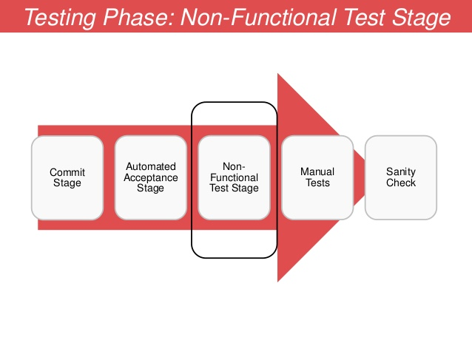

Figure 4.6 : Testing Phase

**Unit testing**

First level is about to test the individual units of the application for the purpose to validate that each unit are performed as designed.

**Integration testing**

Then, all the individual unit is combined and it will been tested in a group. This level of testing is to search any error or faults in interaction between the integrated units.

**System testing**

In this level of testing, the complete combined system is tested to evaluate the system compliance with the specified requirements.

**User Acceptance Testing**

In this level of testing, the complete system then being tested in order to know their acceptability. It is to validate and evaluate the system’s compliance with the business requirement and decide whether it is able to be deliver to the user. User Acceptance Testing is included.

# CHAPTER 5

**CONCLUSION**

## 5.1 Introduction

This chapter will discuss the conclusion for the whole process developed this project. At other hand, this chapter also discuss the constraints of this project and the future work for improvement the project.

## 5.2 Research Constraints

There are several constraints during develop this project. The first, about limited knowledge of Raspberry Pi and limited time to study. Raspberry Pi is a new for technology, for beginner it is need more time to clearly understand the code and have weak connection between device and system also system cannot run properly. During develop this project, the challenges problem when to view the statistic graph.

## 5.3 Future Work

For the future work, the future of system such as login and update will be add to improvement this system. To make this system quality and useful, the system also will be improving for not using the connection of internet for the checking. Besides that, user may update information such number phone if changes.

## 5.4 Conclusion

In conclusion, the user able to get satisfaction by using this system. The user can use this system for checking their heart rate and don’t need to worry if don’t have any time to see the doctor for check-up. The all objective for this project have achieve and the result very satisfied even need more improvement.